* Installed Oracle Java JDK on Ubuntu Linux

sudo apt-add-repository ppa:webupd8team/java

sudo apt-get update

sudo apt-get install oracle-java8-installer

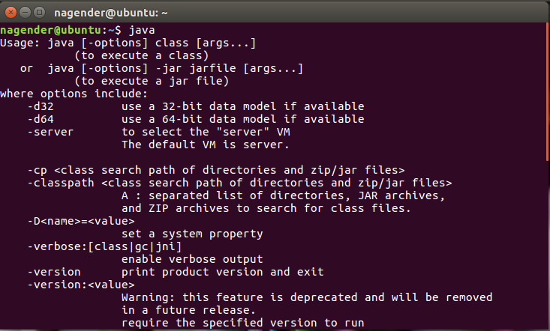

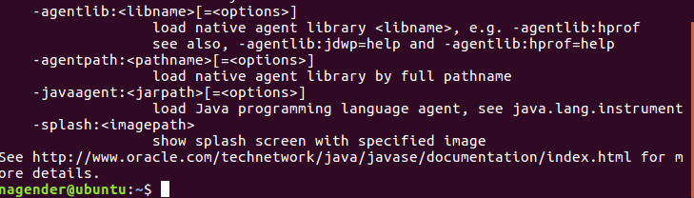

* **Installed nginx web server on Ubuntu**

Sudo apt-get install nginx

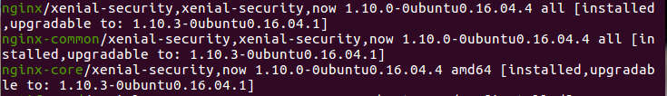

* **Installing Jenkins on Ubuntu**

wget -q -O - https://pkg.jenkins.io/debian/jenkins-ci.org.key | sudo apt-key add -

sudo sh -c 'echo deb http://pkg.jenkins.io/debian-stable binary/ > /etc/apt/sources.list.d/jenkins.list'

sudo apt-get update

sudo apt-get install jenkins

